WIPRO CAPSTONE PROJECT
Code Implementation Report: BlazeDemo Flight Booking Application

Prepared By: Baivab Sarkar
Mentor/ Trainer: Vaishali Sonanis
Framework: Selenium + Java + TestNG + Maven + Page Object Model (POM) + Thread Local
GitHub Link: https://github.com/ThisIs-Developer/Wipro-Capstone-Project
BlazeDemo URL: https://blazedemo.com/

1. Introduction
This document provides the complete source code implementation details for the BlazeDemo Automation Framework. It includes the framework architecture, configuration files, utility classes, page objects, test classes, listeners, CI/CD configuration, and supporting resources used for automated testing.

2. Project Structure
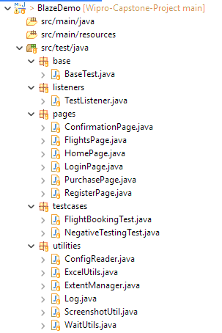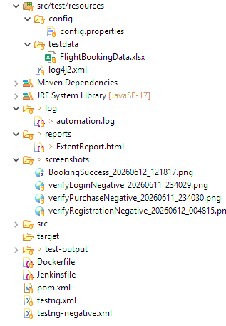

3. source code

Configuration Files

pom.xml

<project xmlns="http://maven.apache.org/POM/4.0.0" xmlns:xsi="http://www.w3.org/2001/XMLSchema-instance" xsi:schemaLocation="http://maven.apache.org/POM/4.0.0 https://maven.apache.org/xsd/maven-4.0.0.xsd">
<modelVersion>4.0.0</modelVersion>
<groupId>BlazeDemo</groupId>
<artifactId>BlazeDemo</artifactId>
<version>0.0.1-SNAPSHOT</version>

<packaging>jar</packaging>
<properties>
<maven.compiler.source>17</maven.compiler.source>
<maven.compiler.target>17</maven.compiler.target>
<project.build.sourceEncoding>UTF-8</project.build.sourceEncoding>
</properties>

<dependencies>
<!-- Source: https://mvnrepository.com/artifact/org.seleniumhq.selenium/selenium-java -->
<dependency>
<groupId>org.seleniumhq.selenium</groupId>
<artifactId>selenium-java</artifactId>
<version>4.44.0</version>
<scope>compile</scope>
</dependency>

<!-- Source: https://mvnrepository.com/artifact/org.testng/testng -->
<dependency>
<groupId>org.testng</groupId>
<artifactId>testng</artifactId>
<version>7.12.0</version>
<scope>test</scope>
</dependency>

<!-- Source: https://mvnrepository.com/artifact/org.apache.poi/poi-ooxml -->
<dependency>
<groupId>org.apache.poi</groupId>
<artifactId>poi-ooxml</artifactId>
<version>5.5.1</version>
<scope>compile</scope>
</dependency>

<!-- Source: https://mvnrepository.com/artifact/commons-io/commons-io -->
<dependency>
<groupId>commons-io</groupId>
<artifactId>commons-io</artifactId>
<version>2.22.0</version>
<scope>compile</scope>
</dependency>

<!-- Source: https://mvnrepository.com/artifact/com.aventstack/extentreports -->
<dependency>
<groupId>com.aventstack</groupId>
<artifactId>extentreports</artifactId>
<version>5.1.2</version>
<scope>compile</scope>
</dependency>

<!-- Source: https://mvnrepository.com/artifact/org.apache.logging.log4j/log4j-api -->
<dependency>
<groupId>org.apache.logging.log4j</groupId>
<artifactId>log4j-api</artifactId>
<version>2.26.0</version>
<scope>compile</scope>
</dependency>

<!-- Source: https://mvnrepository.com/artifact/org.apache.logging.log4j/log4j-core -->
<dependency>
<groupId>org.apache.logging.log4j</groupId>
<artifactId>log4j-core</artifactId>
<version>2.26.0</version>
<scope>compile</scope>
</dependency>
</dependencies>

<build>
<plugins>
<!-- Maven Compiler Plugin -->
<plugin>
<groupId>org.apache.maven.plugins</groupId>
<artifactId>maven-compiler-plugin</artifactId>
<version>3.15.0</version>
<configuration>
<source>17</source>
<target>17</target>
</configuration>
</plugin>

<!-- Maven Surefire Plugin for TestNG -->
<plugin>
<groupId>org.apache.maven.plugins</groupId>
<artifactId>maven-surefire-plugin</artifactId>
<version>3.5.4</version>
<configuration>
<suiteXmlFiles>
<suiteXmlFile>testng.xml</suiteXmlFile>
</suiteXmlFiles>
</configuration>
</plugin>
</plugins>
</build>

</project>

config.properties

browser=chrome
url=https://blazedemo.com/

log4j2.xml

<?xml version="1.0" encoding="UTF-8"?>
<Configuration status="WARN">

<Appenders>
<Console name="Console" target="SYSTEM_OUT">
<PatternLayout pattern="%d{yyyy-MM-dd HH:mm:ss} [%t] %-5level %c{1} - %msg%n"/>
</Console>
<File name="FileLogger"
fileName="log/automation.log"
append="false">
<PatternLayout pattern="%d{yyyy-MM-dd HH:mm:ss} [%t] %-5level %c{1} - %msg%n"/>
</File>
</Appenders>
<Loggers>
<Root level="info">
<AppenderRef ref="Console"/>
<AppenderRef ref="FileLogger"/>
</Root>
</Loggers>
</Configuration>

testng.xml
<!DOCTYPE suite SYSTEM "https://testng.org/testng-1.0.dtd">

<suite name="FlightBookingSuite">
<listeners>
<listener class-name="listeners.TestListener"/>
</listeners>

<!-- <test name="SmokeTests">
<groups><run><include name="smoke"/></run>
</groups>
<classes>
<class name="testcases.FlightBookingTest"/>
</classes>
</test>-->
<test name="FlightBookingTests" group-by-instances="true">
<classes>
<class name="testcases.FlightBookingTest"/>
</classes>
</test>
</suite>

testng-negative.xml
<!DOCTYPE suite SYSTEM "https://testng.org/testng-1.0.dtd">

<suite name="NegativeTestSuite">
<listeners>
<listener class-name="listeners.TestListener"/>
</listeners>
<test name="NegativeTests">
<classes>
<class name="testcases.NegativeTestingTest"/>
</classes>
</test>
</suite>

Jenkinsfile

pipeline {
agent any
tools {
maven 'Maven3'
}

stages {
stage('Checkout') {
steps {
git branch: 'main',
url: 'https://github.com/ThisIs-Developer/Wipro-Capstone-Project'
}
}

stage('Build') {
steps {
dir('BlazeDemo') {
bat 'mvn clean compile'
}
}
}

stage('Compile') {
steps {
dir('BlazeDemo') {
bat 'mvn compile'
}
}
}

stage('Test') {
steps {
dir('BlazeDemo') {
bat 'mvn test'
}
}
}

stage('Docker Build') {
steps {
dir('BlazeDemo') {
bat 'docker build -t blazedemo-framework .'
}
}
}

stage('Docker Run') {
steps {
bat 'docker run --rm blazedemo-framework'
}
}
}

post {

success {
echo 'Build Successful'
}

failure {
echo 'Build Failed'
}

always {
echo 'Pipeline Execution Completed'
}
}
}

Dockerfile

FROM selenium/standalone-chrome:latest
USER root
WORKDIR /app
RUN apt-get update && apt-get install -y maven openjdk-25-jdk
COPY . .
RUN mvn clean install -DskipTests
CMD ["mvn", "test", "-DsuiteXmlFile=testng.xml"]

Base Layer

BaseTest.java

package base;

import java.time.Duration;

import org.openqa.selenium.WebDriver;
import org.openqa.selenium.chrome.ChromeDriver;
import org.openqa.selenium.chrome.ChromeOptions;
import org.openqa.selenium.edge.EdgeDriver;
import org.openqa.selenium.firefox.FirefoxDriver;

import org.testng.annotations.AfterClass;
import org.testng.annotations.BeforeClass;

import utilities.ConfigReader;
import utilities.Log;

public class BaseTest {

public WebDriver driver;

@BeforeClass
public void setup() {

String browser = ConfigReader.getProperty("browser");

switch (browser.toLowerCase()) {
case "chrome":
ChromeOptions options = new ChromeOptions();

options.addArguments("--headless=new");
options.addArguments("--no-sandbox");
options.addArguments("--disable-dev-shm-usage");
options.addArguments("--disable-gpu");
options.addArguments("--remote-allow-origins=*");

driver = new ChromeDriver(options);

Log.info("Launching Browser : " + browser);
break;

case "firefox":
driver = new FirefoxDriver();
Log.info("Launching Browser : " + browser);
break;

case "edge":
driver = new EdgeDriver();
Log.info("Launching Browser : " + browser);
break;

default:
Log.error("Unsupported Browser : " + browser);
throw new RuntimeException("Unsupported Browser : " + browser);
}

driver.manage().window().maximize();
driver.manage().timeouts().implicitlyWait(Duration.ofSeconds(10));
driver.get(ConfigReader.getProperty("url"));
Log.info("Application Opened");
}

@AfterClass
public void tearDown() {
if (driver != null) {
Log.info("Closing Browser");
driver.quit();
}
}
}

Page Object Modal

HomePage.java

package pages;

import org.openqa.selenium.By;
import org.openqa.selenium.WebDriver;
import org.openqa.selenium.WebElement;

import org.openqa.selenium.support.ui.Select;

import utilities.WaitUtils;

public class HomePage {

private WebDriver driver;
private WaitUtils wait;

public HomePage(WebDriver driver) {
this.driver = driver;
this.wait = new WaitUtils(driver);
}

private By departureDropdown = By.name("fromPort");
private By destinationDropdown = By.name("toPort");
private By findFlightsButton = By.cssSelector("input[type='submit']");

public String getPageTitle() {
return driver.getTitle();
}

public String getPageUrl() {
return driver.getCurrentUrl();
}

public boolean isDepartureDropdownDisplayed() {
WebElement element = driver.findElement(departureDropdown);
wait.waitForVisibility(element);
return element.isDisplayed();
}

public boolean isDestinationDropdownDisplayed() {
WebElement element = driver.findElement(destinationDropdown);
wait.waitForVisibility(element);
return element.isDisplayed();
}

public boolean isFindFlightsButtonDisplayed() {
WebElement element = driver.findElement(findFlightsButton);
wait.waitForVisibility(element);
return element.isDisplayed();
}

public void selectDepartureCity(String city) {
Select select = new Select(driver.findElement(departureDropdown));
select.selectByVisibleText(city);
}

public void selectDestinationCity(String city) {
Select select = new Select(driver.findElement(destinationDropdown));
select.selectByVisibleText(city);
}

public void clickFindFlights() {
WebElement button = driver.findElement(findFlightsButton);
wait.waitForClickable(button);
button.click();
}
}

FlightsPage.java

package pages;

import java.util.List;

import org.openqa.selenium.By;
import org.openqa.selenium.WebDriver;
import org.openqa.selenium.WebElement;

import utilities.WaitUtils;

public class FlightsPage {

private WebDriver driver;
private WaitUtils wait;

private By flightTable = By.cssSelector("table[class='table']");
private By flightRows = By.xpath("/html/body/div[2]/table/tbody/tr");
private By chooseFlightButtons = By.cssSelector("input[value='Choose This Flight']");

public FlightsPage(WebDriver driver) {
this.driver = driver;
this.wait = new WaitUtils(driver);
}

public boolean isFlightTableDisplayed() {

WebElement table = driver.findElement(flightTable);
wait.waitForVisibility(table);
return table.isDisplayed();
}

public int getFlightCount() {
List<WebElement> rows = driver.findElements(flightRows);
// System.out.println("Total Flight Count: "+rows.size());
return rows.size();
}

public boolean hasFlights() {
return getFlightCount() > 0;
}

public void chooseFirstFlight() {
List<WebElement> buttons = driver.findElements(chooseFlightButtons);
if (buttons.isEmpty()) {
throw new RuntimeException("No Flight Found");
}
wait.waitForClickable(buttons.get(0));
buttons.get(0).click();
}
}

PurchasePage.java

package pages;

import org.openqa.selenium.By;
import org.openqa.selenium.WebDriver;
import org.openqa.selenium.WebElement;

import org.openqa.selenium.support.ui.Select;

import utilities.WaitUtils;

public class PurchasePage {

private WebDriver driver;
private WaitUtils wait;

private By priceText = By.xpath("/html/body/div[2]/p[3]");
private By totalCost = By.xpath("/html/body/div[2]/p[4]");
private By purchaseFlightButton = By.cssSelector("input[value='Purchase Flight']");
private By nameField = By.id("inputName");
private By addressField = By.id("address");
private By cityField = By.id("city");
private By stateField = By.id("state");
private By zipCodeField = By.id("zipCode");
private By cardTypeDropdown = By.id("cardType");
private By cardNumberField = By.id("creditCardNumber");
private By monthField = By.id("creditCardMonth");
private By yearField = By.id("creditCardYear");
private By nameOnCardField = By.id("nameOnCard");

public PurchasePage(WebDriver driver) {
this.driver = driver;
this.wait = new WaitUtils(driver);
}

public boolean isPriceDisplayed() {
WebElement price = driver.findElement(priceText);
wait.waitForVisibility(price);
return price.isDisplayed();
}

public boolean isTotalCostDisplayed() {
WebElement cost = driver.findElement(totalCost);
wait.waitForVisibility(cost);
return cost.isDisplayed();
}

public void enterName(String name) {
driver.findElement(nameField).sendKeys(name);
}

public void enterAddress(String address) {
driver.findElement(addressField).sendKeys(address);
}

public void enterCity(String city) {
driver.findElement(cityField).sendKeys(city);
}

public void enterState(String state) {
driver.findElement(stateField).sendKeys(state);
}

public void enterZipCode(String zipCode) {
driver.findElement(zipCodeField).sendKeys(zipCode);
}

public void selectCardType(String cardType) {
Select select = new Select(driver.findElement(cardTypeDropdown));
select.selectByVisibleText(cardType);
}

public void enterCardNumber(String cardNumber) {
driver.findElement(cardNumberField).sendKeys(cardNumber);
}

public void enterMonth(String month) {
driver.findElement(monthField).clear();
driver.findElement(monthField).sendKeys(month);
}

public void enterYear(String year) {
driver.findElement(yearField).clear();
driver.findElement(yearField).sendKeys(year);
}

public void enterNameOnCard(String nameOnCard) {
driver.findElement(nameOnCardField).sendKeys(nameOnCard);
}

public void clickPurchaseFlight() {
WebElement button = driver.findElement(purchaseFlightButton);
wait.waitForClickable(button);
button.click();
}
}

ConfirmationPage.java

package pages;

import org.openqa.selenium.By;
import org.openqa.selenium.WebDriver;
import org.openqa.selenium.WebElement;

import utilities.WaitUtils;

public class ConfirmationPage {

private WebDriver driver;
private WaitUtils wait;

private By successMessage = By.tagName("h1");
private By purchaseId = By.xpath("/html/body/div[2]/div/table/tbody/tr[1]/td[2]");
private By status = By.xpath("/html/body/div[2]/div/table/tbody/tr[2]/td[2]");
private By amount = By.xpath("/html/body/div[2]/div/table/tbody/tr[3]/td[2]");
private By cardNumber = By.xpath("/html/body/div[2]/div/table/tbody/tr[4]/td[2]");
private By date = By.xpath("/html/body/div[2]/div/table/tbody/tr[7]/td[2]");

public ConfirmationPage(WebDriver driver) {
this.driver = driver;
this.wait = new WaitUtils(driver);
}

public String getSuccessMessage() {
WebElement element = driver.findElement(successMessage);
wait.waitForVisibility(element);
return element.getText();
}

public String getPurchaseId() {
return driver.findElement(purchaseId).getText();
}

public String getStatus() {
return driver.findElement(status).getText();
}

public String getAmount() {
return driver.findElement(amount).getText();
}

public String getCardNumber() {
return driver.findElement(cardNumber).getText();
}

public String getDate() {
return driver.findElement(date).getText();
}
}

LoginPage.java

package pages;

import org.openqa.selenium.By;
import org.openqa.selenium.WebDriver;

public class LoginPage {

WebDriver driver;

public LoginPage(WebDriver driver) {
this.driver = driver;
}

private By email = By.id("email");
private By password = By.id("password");
private By loginButton = By.xpath("//button[contains(normalize-space(),'Login')]");

public void enterEmail(String emailId) {
driver.findElement(email).sendKeys(emailId);
}

public void enterPassword(String pwd) {
driver.findElement(password).sendKeys(pwd);
}

public void clickLogin() {
driver.findElement(loginButton).click();
}

public void login(String emailId, String pwd) {
enterEmail(emailId);
enterPassword(pwd);
clickLogin();
}

public boolean is419ErrorDisplayed() {

return driver.getPageSource().contains("419") || driver.getPageSource().contains("Page Expired");
}
}

RegisterPage.java

package pages;

import org.openqa.selenium.By;
import org.openqa.selenium.WebDriver;

public class RegisterPage {

WebDriver driver;

public RegisterPage(WebDriver driver) {
this.driver = driver;
}

private By name = By.id("name");
private By company = By.id("company");
private By email = By.id("email");
private By password = By.id("password");
private By confirmPassword = By.id("password-confirm");
private By registerButton = By.xpath("//button[contains(normalize-space(),'Register')]");

public void registerUser(String userName, String companyName, String emailId, String pwd, String confirmPwd) {
driver.findElement(name).sendKeys(userName);
driver.findElement(company).sendKeys(companyName);
driver.findElement(email).sendKeys(emailId);
driver.findElement(password).sendKeys(pwd);
driver.findElement(confirmPassword).sendKeys(confirmPwd);
driver.findElement(registerButton).click();
}

public boolean is419ErrorDisplayed() {
return driver.getPageSource().contains("419") || driver.getPageSource().contains("Page Expired");
}
}

Utility Classes

ConfigReader.java

package utilities;

import java.io.FileInputStream;
import java.util.Properties;

public class ConfigReader {

private static Properties properties;

static {
try {
properties = new Properties();
FileInputStream fis = new FileInputStream("src/test/resources/config/config.properties");
properties.load(fis);
} catch (Exception e) {
throw new RuntimeException("Unable to load config file", e);
}
}

public static String getProperty(String key) {
return properties.getProperty(key);
}
}

ExcelUtils.java

package utilities;

import java.io.FileInputStream;

import org.apache.poi.ss.usermodel.DataFormatter;
import org.apache.poi.xssf.usermodel.XSSFSheet;
import org.apache.poi.xssf.usermodel.XSSFWorkbook;

public class ExcelUtils {

public static Object[][] getExcelData(String filePath, String sheetName) {
try (FileInputStream fis = new FileInputStream(filePath);
XSSFWorkbook workbook = new XSSFWorkbook(fis)) {

XSSFSheet sheet = workbook.getSheet(sheetName);
int rowCount = sheet.getLastRowNum();
int cellCount = sheet.getRow(0).getLastCellNum();

Object[][] data = new Object[rowCount][cellCount];
DataFormatter formatter = new DataFormatter();
for (int i = 1; i <= rowCount; i++) {
for (int j = 0; j < cellCount; j++) {
data[i - 1][j] = formatter.formatCellValue(sheet.getRow(i).getCell(j));
}
}
return data;
} catch (Exception e) {
throw new RuntimeException("Unable to read excel data", e);
}
}
}

WaitUtils.java

package utilities;

import java.time.Duration;

import org.openqa.selenium.WebDriver;
import org.openqa.selenium.WebElement;
import org.openqa.selenium.support.ui.ExpectedConditions;
import org.openqa.selenium.support.ui.WebDriverWait;

public class WaitUtils {

private WebDriverWait wait;

public WaitUtils(WebDriver driver) {
try {
wait = new WebDriverWait(driver,Duration.ofSeconds(20));
} catch (Exception e) {
throw new RuntimeException("Unable to initialize WaitUtils", e);
}
}

public void waitForVisibility(WebElement element) {
try {
wait.until(ExpectedConditions.visibilityOf(element));
} catch (Exception e) {
throw new RuntimeException("Element not visible", e);
}
}

public void waitForClickable(WebElement element) {

try {
wait.until(ExpectedConditions.elementToBeClickable(element));
} catch (Exception e) {
throw new RuntimeException("Element not clickable", e);
}
}

public void waitForTitle(String title) {

try {
wait.until(ExpectedConditions.titleContains(title));
} catch (Exception e) {
throw new RuntimeException("Title not found : " + title, e);
}
}

public void waitForUrl(String url) {

try {
wait.until(ExpectedConditions.urlContains(url));
} catch (Exception e) {
throw new RuntimeException("URL not found : " + url, e);
}
}
}

ScreenshotUtil.java

package utilities;

import java.io.File;
import java.io.IOException;
import java.time.LocalDateTime;
import java.time.format.DateTimeFormatter;

import org.apache.commons.io.FileUtils;
import org.openqa.selenium.OutputType;
import org.openqa.selenium.TakesScreenshot;
import org.openqa.selenium.WebDriver;

public class ScreenshotUtil {

public static String captureScreenshot(WebDriver driver, String testName) {

try {
String timestamp =LocalDateTime.now().format(DateTimeFormatter.ofPattern("yyyyMMdd_HHmmss"));
String filePath = "screenshots/"+ testName+ "_"+ timestamp+ ".png";

File source =((TakesScreenshot) driver).getScreenshotAs(OutputType.FILE);
File destination = new File(filePath);
FileUtils.copyFile(source,destination);
return filePath;
} catch (IOException e) {
throw new RuntimeException("Unable to capture screenshot", e);
}
}
}

ExtentManager.java

package utilities;

import com.aventstack.extentreports.ExtentReports;
import com.aventstack.extentreports.reporter.ExtentSparkReporter;

public class ExtentManager {

private static ExtentReports extent;
private ExtentManager() {}

public static ExtentReports getInstance() {
if (extent == null) {
ExtentSparkReporter sparkReporter = new ExtentSparkReporter( "reports/ExtentReport.html");
sparkReporter.config().setDocumentTitle("Flight Booking Automation Report");
sparkReporter.config().setReportName( "Automation Execution Results");

extent = new ExtentReports();
extent.attachReporter(sparkReporter);
}
return extent;
}
}

Log.java

package utilities;

import org.apache.logging.log4j.LogManager;
import org.apache.logging.log4j.Logger;

public class Log {

private static final Logger logger = LogManager.getLogger(Log.class);
private Log() {}
public static void info(String message) {
logger.info(message);
}
public static void error(String message) {
logger.error(message);
}
}

Listener Implementation

TestListener.java

package listeners;

import org.testng.ITestListener;
import org.testng.ITestResult;

import base.BaseTest;
import utilities.Log;
import utilities.ScreenshotUtil;

public class TestListener implements ITestListener {

@Override
public void onTestStart(ITestResult result) {
System.out.println("STARTED : "+ result.getName());
}

@Override
public void onTestSuccess(ITestResult result) {
System.out.println("PASSED : "+ result.getName());
}

@Override
public void onTestFailure(ITestResult result) {
System.out.println("FAILED : "+ result.getName());
try {
BaseTest testClass = (BaseTest) result.getInstance();
String screenshotPath = ScreenshotUtil.captureScreenshot(testClass.driver,result.getName());
Log.error("Test Failed : "+ result.getName());
Log.error("Failure Screenshot Saved : "+ screenshotPath);
} catch (Exception e) {
Log.error("Unable to capture screenshot : "+ e.getMessage());
}
}

@Override
public void onTestSkipped(ITestResult result) {
System.out.println("SKIPPED : "+ result.getName());
}}

Positive Test Suite Implementation

FlightBookingTest.java

package testcases;

import org.testng.Assert;
import org.testng.annotations.DataProvider;
import org.testng.annotations.Factory;
import org.testng.annotations.Test;

import com.aventstack.extentreports.ExtentReports;
import com.aventstack.extentreports.ExtentTest;

import base.BaseTest;
import pages.ConfirmationPage;
import pages.FlightsPage;
import pages.HomePage;
import pages.PurchasePage;
import utilities.ExcelUtils;
import utilities.ExtentManager;
import utilities.Log;
import utilities.ScreenshotUtil;

public class FlightBookingTest extends BaseTest {

private final ExtentReports extent = ExtentManager.getInstance();
private ExtentTest test;

private HomePage homePage;
private FlightsPage flightsPage;
private PurchasePage purchasePage;
private ConfirmationPage confirmationPage;

private String departureCity;
private String destinationCity;

private String name;
private String address;
private String city;
private String state;
private String zipCode;

private String cardType;
private String cardNumber;
private String month;
private String year;
private String nameOnCard;

@DataProvider(name = "bookingData")
public static Object[][] bookingData() {
return ExcelUtils.getExcelData("src/test/resources/testdata/FlightBookingData.xlsx","BookingData");
}

@Factory(dataProvider = "bookingData")
public FlightBookingTest(String departureCity, String destinationCity, String name, String address, String city, String state,
String zipCode, String cardType, String cardNumber, String month, String year, String nameOnCard) {
this.departureCity = departureCity;
this.destinationCity = destinationCity;
this.name = name;
this.address = address;
this.city = city;
this.state = state;
this.zipCode = zipCode;
this.cardType = cardType;
this.cardNumber = cardNumber;
this.month = month;
this.year = year;
this.nameOnCard = nameOnCard;
}

@Test(priority=1, groups={"smoke", "regression"})
public void verifyHomePage() {
test = extent.createTest(departureCity+"->"+destinationCity);
Log.info("Home Page Verification Started");

homePage = new HomePage(driver);
Assert.assertEquals(homePage.getPageTitle(), "BlazeDemo");
Assert.assertEquals(homePage.getPageUrl(), "https://blazedemo.com/");
Assert.assertTrue(homePage.isDepartureDropdownDisplayed());
Assert.assertTrue(homePage.isDestinationDropdownDisplayed());
Assert.assertTrue(homePage.isFindFlightsButtonDisplayed());
homePage.selectDepartureCity(departureCity);
homePage.selectDestinationCity(destinationCity);
homePage.clickFindFlights();

test.pass("Home Page Verified Successfully");
Log.info("Home Page Verification Completed");
}

@Test(priority = 2,groups = {"regression"},dependsOnMethods = "verifyHomePage")
public void verifyFlightSearch() {
test = extent.createTest("Verify Flight Search");
Log.info("Flight Search Verification Started");

flightsPage = new FlightsPage(driver);
Assert.assertTrue(flightsPage.isFlightTableDisplayed());
Assert.assertTrue(flightsPage.hasFlights());
flightsPage.chooseFirstFlight();

test.pass("Flight Search Verified");
Log.info("Flight Search Verification Completed");
}

@Test(priority = 3, groups = { "regression" }, dependsOnMethods = "verifyFlightSearch")
public void verifyPurchasePage() {
test = extent.createTest("Verify Purchase Page");
Log.info("Purchase Page Verification Started");

purchasePage = new PurchasePage(driver);
Assert.assertTrue(purchasePage.isPriceDisplayed());
Assert.assertTrue(purchasePage.isTotalCostDisplayed());
purchasePage.enterName(name);
purchasePage.enterAddress(address);
purchasePage.enterCity(city);
purchasePage.enterState(state);
purchasePage.enterZipCode(zipCode);
purchasePage.selectCardType(cardType);
purchasePage.enterCardNumber(cardNumber);
purchasePage.enterMonth(month);
purchasePage.enterYear(year);
purchasePage.enterNameOnCard(nameOnCard);
purchasePage.clickPurchaseFlight();

test.pass("Passenger And Payment Details Submitted");
Log.info("Purchase Page Verification Completed");
}

@Test(priority = 4,groups = {"regression"},dependsOnMethods = "verifyPurchasePage")
public void verifyBookingConfirmation() throws Exception {
test = extent.createTest("Verify Booking Confirmation");
Log.info("Confirmation Verification Started");

confirmationPage = new ConfirmationPage(driver);
Assert.assertEquals(confirmationPage.getSuccessMessage(),"Thank you for your purchase today!");
Assert.assertFalse(confirmationPage.getPurchaseId().isEmpty());
Assert.assertEquals(confirmationPage.getStatus(),"PendingCapture");
Assert.assertFalse(confirmationPage.getAmount().isEmpty());
Assert.assertFalse(confirmationPage.getCardNumber().isEmpty());
Assert.assertFalse(confirmationPage.getDate().isEmpty());

String screenshotPath = ScreenshotUtil.captureScreenshot(driver,"BookingSuccess");

test.addScreenCaptureFromPath(screenshotPath);
Log.info("Screenshot Captured");
test.pass("Booking Confirmation Verified");
Log.info("Booking Confirmation Completed");
extent.flush();
}
}

Listener Implementation

NegativeTestingTest.java

package testcases;

import org.testng.Assert;
import org.testng.annotations.DataProvider;
import org.testng.annotations.Test;

import base.BaseTest;
import pages.ConfirmationPage;
import pages.LoginPage;
import pages.PurchasePage;
import pages.RegisterPage;
import utilities.ConfigReader;

public class NegativeTestingTest extends BaseTest {

private RegisterPage registerPage;
private LoginPage loginPage;
private PurchasePage purchasePage;
private ConfirmationPage confirmationPage;

@DataProvider(name = "userData")
public Object[][] userData() {
return new Object[][] {
{"Baivab Sarkar", "Wipro", "baivab@test.com", "Test@123", "Test@123"}
};
}

@DataProvider(name = "purchaseNegativeData")
public Object[][] purchaseNegativeData() {
return new Object[][] {
{"", "123456", "@#$%^&*", "98765", "ABCDEF", "Visa", "1","99", "1900", "@@@###"}
};
}

@Test(priority = 1, dataProvider = "userData")
public void verifyRegistrationNegative(String name, String company, String email, String password, String confirmPassword){
driver.get(ConfigReader.getProperty("url")+"register");
registerPage = new RegisterPage(driver);

registerPage.registerUser(name, company, email, password, confirmPassword);
Assert.assertTrue(registerPage.is419ErrorDisplayed(),"Known Defect: Registration request results in HTTP 419 Page Expired error.");
}

@Test(priority = 2, dataProvider = "userData")
public void verifyLoginNegative(String name, String company, String email, String password, String confirmPassword){
driver.get(ConfigReader.getProperty("url") + "login");
loginPage = new LoginPage(driver);

loginPage.login(email,password);
Assert.assertTrue(loginPage.is419ErrorDisplayed(),"Known Defect: Login request results in HTTP 419 Page Expired error.");
}

@Test(priority = 3, dataProvider = "purchaseNegativeData")
public void verifyPurchaseNegative(String name, String address, String city,
String state, String zipCode, String cardType, String cardNumber, String month, String year, String nameOnCard){

driver.get(ConfigReader.getProperty("url") + "purchase.php");
purchasePage = new PurchasePage(driver);

purchasePage.enterName(name);
purchasePage.enterAddress(address);
purchasePage.enterCity(city);
purchasePage.enterState(state);
purchasePage.enterZipCode(zipCode);
purchasePage.selectCardType(cardType);
purchasePage.enterCardNumber(cardNumber);
purchasePage.enterMonth(month);
purchasePage.enterYear(year);
purchasePage.enterNameOnCard(nameOnCard);
purchasePage.clickPurchaseFlight();

confirmationPage = new ConfirmationPage(driver);

Assert.assertEquals(
confirmationPage.getSuccessMessage(),
"Thank you for your purchase today!",
"Critical Defect: System generated a booking confirmation despite invalid passenger and payment information.");

Assert.assertFalse(
confirmationPage.getPurchaseId().isEmpty(),
"Critical Defect: Booking ID was generated for invalid booking data.");

Assert.assertEquals(
confirmationPage.getStatus(),
"PendingCapture",
"Critical Defect: Invalid booking received a valid transaction status.");

Assert.assertFalse(
confirmationPage.getAmount().isEmpty(),
"Critical Defect: Amount was generated despite invalid input data.");

Assert.assertFalse(
confirmationPage.getCardNumber().isEmpty(),
"Critical Defect: Invalid payment information was accepted.");

Assert.assertFalse(
confirmationPage.getDate().isEmpty(),
"Critical Defect: Confirmation record was created for invalid booking data.");
}
}

Test Data

FlightBookingData.xlsx

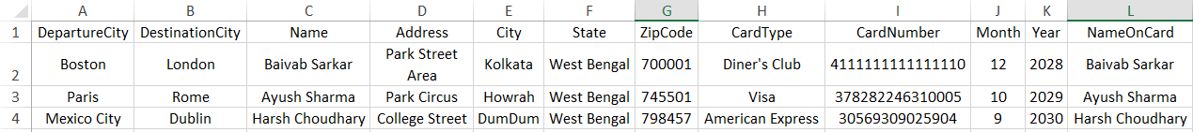

4. Project link & Screenshots & Evidence
Extent Reports, TestNG Reports, screenshots, and execution logs are generated automatically and made available after each execution for analysis and traceability.
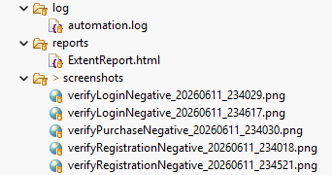

Run as TestNG Suite in IDE

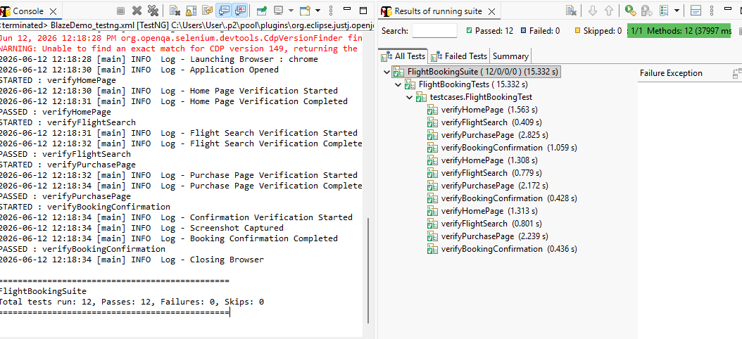
Log4j2 Logs
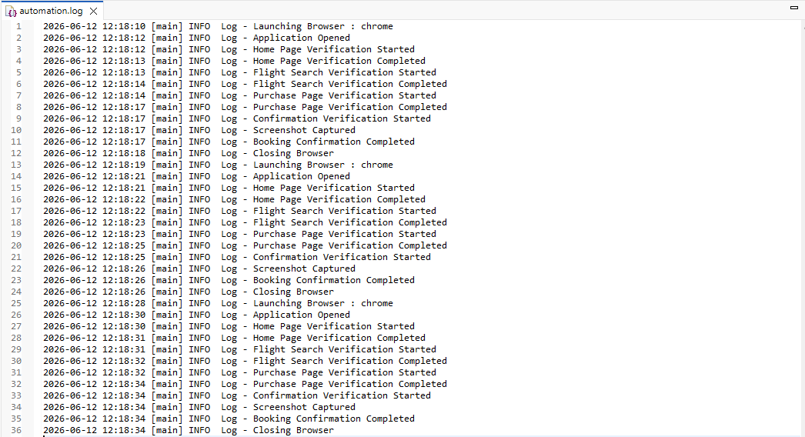
ExtentReport (.html)

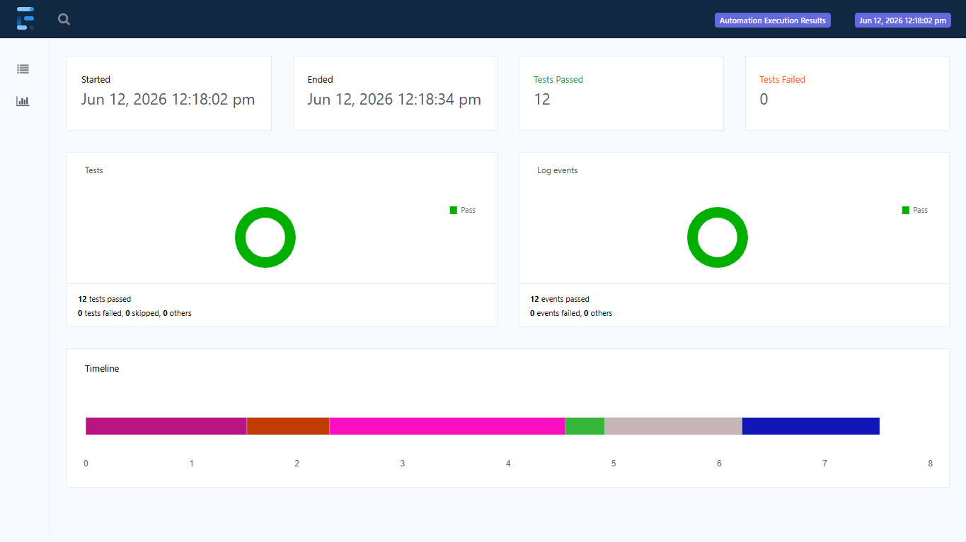

13. CI/CD & Containerization
The automation framework is designed for easy execution across different environments and supports automated build and test execution through containerization and CI/CD integration.
- Jenkins (CI/CD Pipeline):
A Jenkins pipeline is configured to automate the testing workflow. The pipeline pulls the latest code from the Git repository, builds the Maven project, executes the TestNG test suites, generates execution reports, and archives test artifacts for review.
- Docker (Containerization):
The framework is containerized using a custom Dockerfile, allowing the complete Selenium-TestNG automation suite to run inside a Docker container. This ensures a consistent execution environment and eliminates machine-specific dependency issues.
Jenkins runs
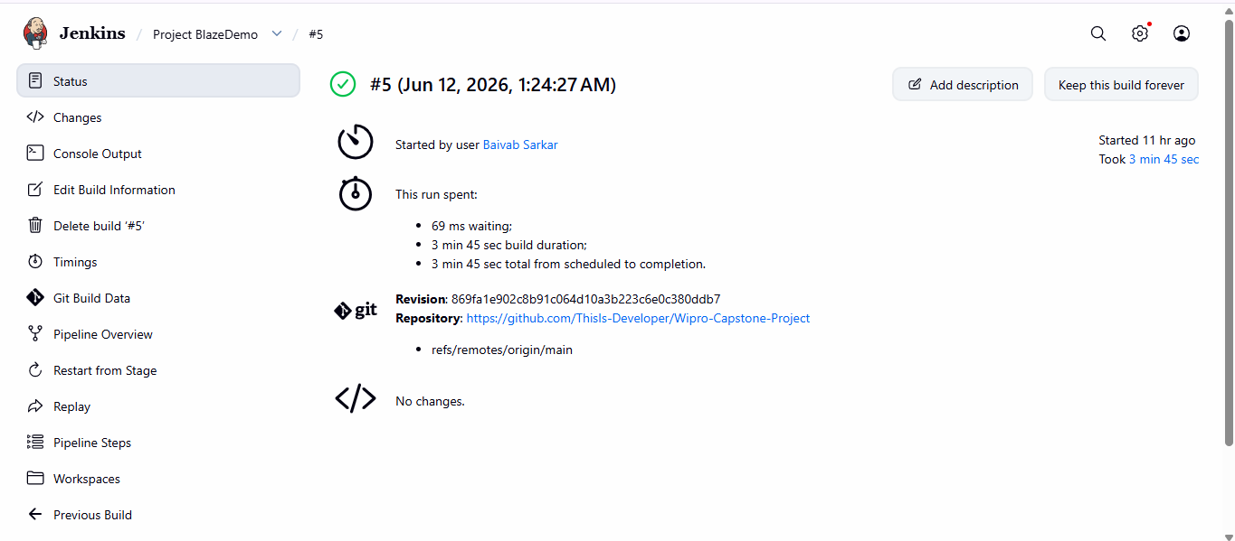
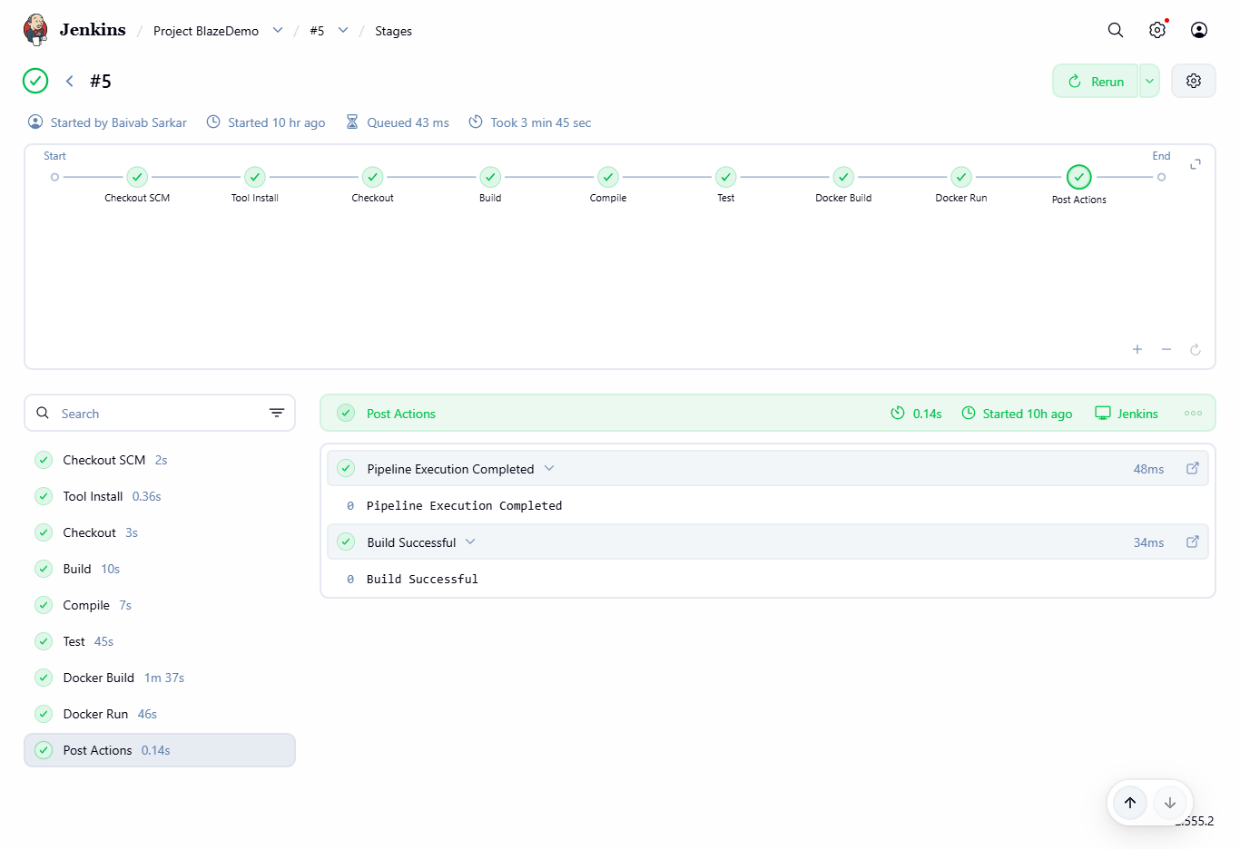
Docker Image Run and Logs

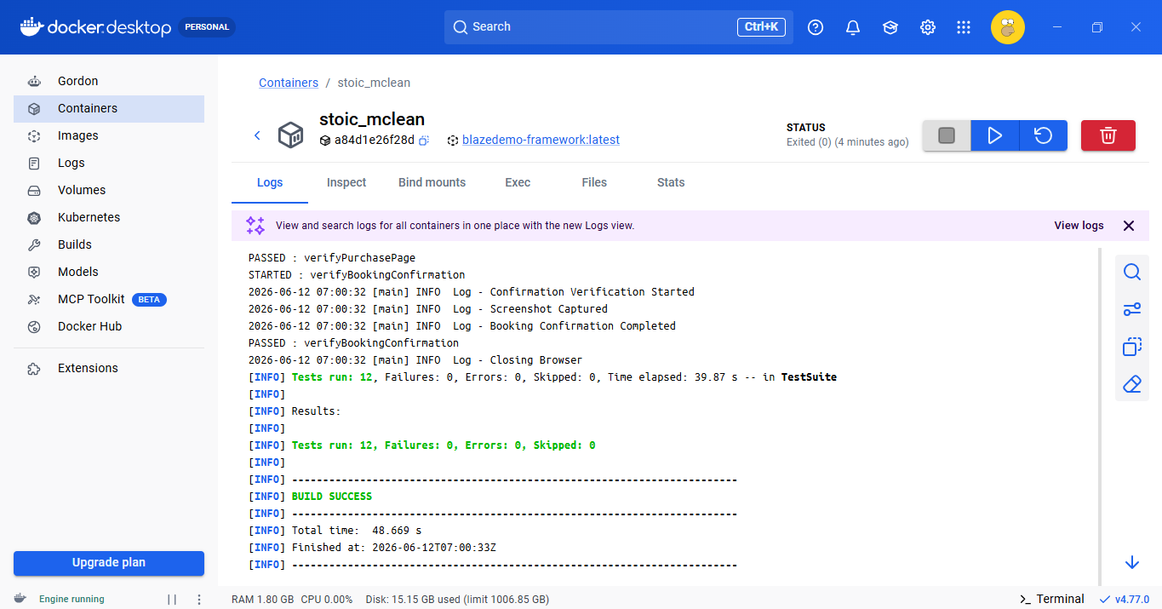

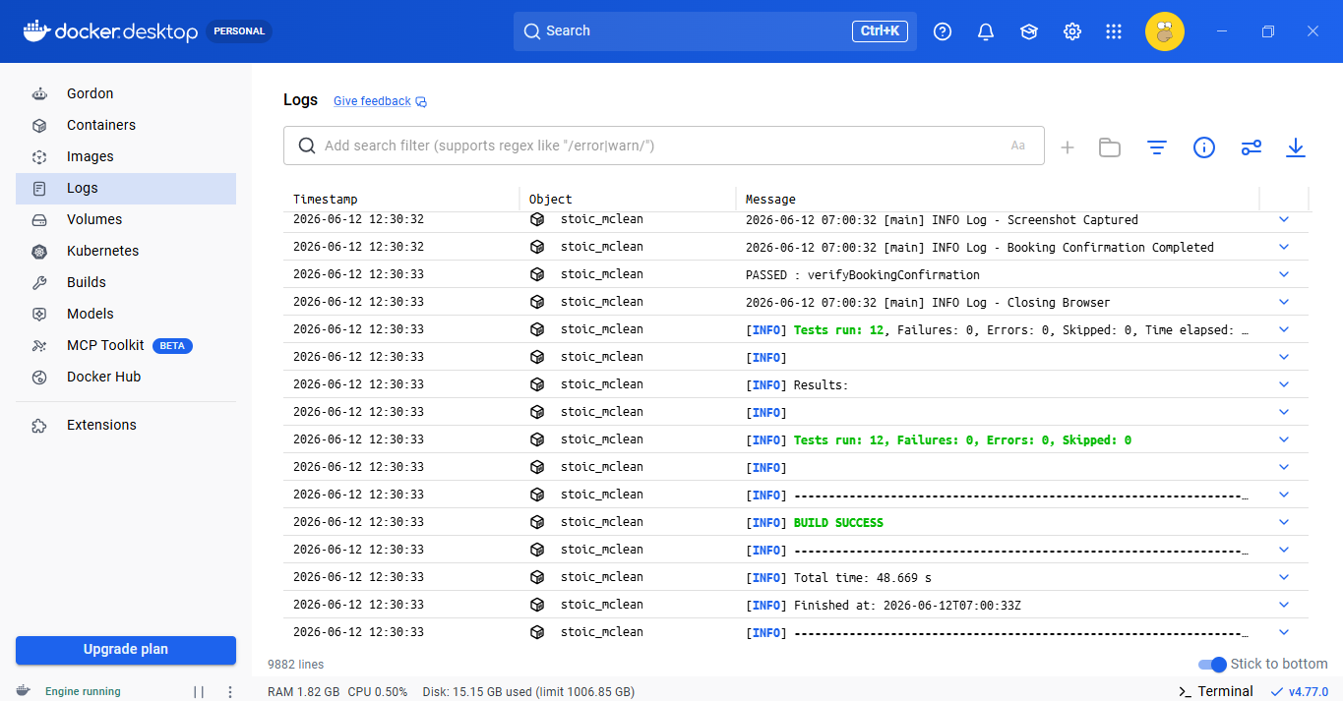

5. Conclusion
The BlazeDemo Automation Framework successfully demonstrates a scalable, maintainable, and data-driven test automation solution. The framework validates end-to-end flight booking functionality, identifies application defects through negative testing, and supports automated execution using Docker and Jenkins.

